**Project Proposal**



**Data communication and network lab**

**Submitted by: Wajid ullah, Muhammad Ali, Tiham khan**

**Registration No: 19pwcse1759, 19pwcse1801, 19pwcse1807**

**Class Section: A**

**Submitted to: Sir Faiz Ullah**

**Date: 27/07/2022**

**University of Engineering and Technology, Peshawar**

**Department of Computer Systems Engineering**

**Project: -**

**“Implementation of network connection by subnetting”**

**Component: -**

* Node devices (laptop, printer etc).
* End devices (router, switches).
* Connection cables.

**Description: -**

An organization or client requests us for network to be design, which has the following simplification.

**Design a network in cisco packet tracer to connect ACCOUNT and DELIVERY or more departments through the following**

a. Each department should contain at least 2 PC’s.

b. Appropriate number of switches and router should be used in the network.

c. Using the given network address 192.168.40.0 all interface should be configured with appropriate IP address, subnet mask and gateway.

d. All devices in the network should be connected using appropriate cable.

e. Test the connectivity between ACCOUNT and DELIVERY department PC’s in DELIVERY department should be able to ping the PC’s in ACCOUNT department.

Here we are required to design a network which connect two subnets (network) with the given network address 192.168.40.0.

**Router configuration: -**

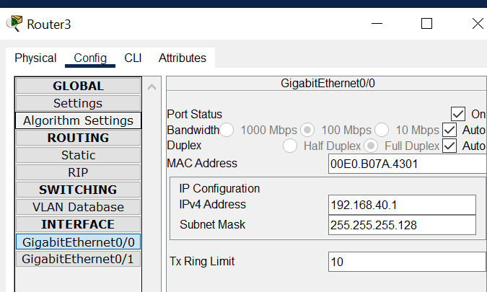

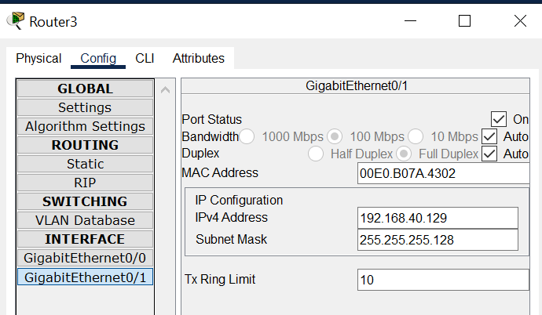

**Model design: -**

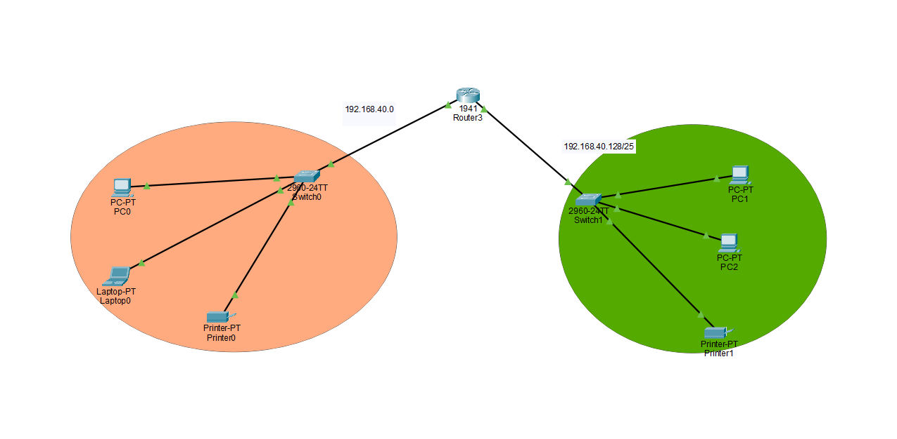

**Connection of two host: -**

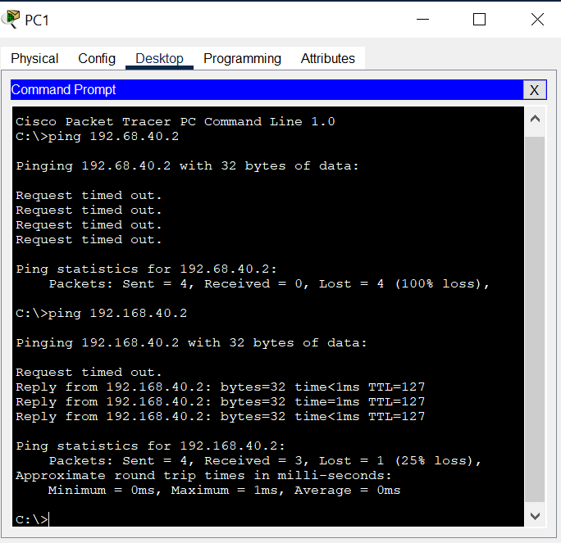

255.255.255.0/25

11111111.11111111.11111111. 10000000

255.255.255.128==(subnet mask)

1st subnet:

subnet mask = 255.255.255.128

Network ID == 192.168.40.0

Range of valid host = 192.168.40.1-- 192.168.40.126

Broadcast ID== 192.168.40.127

2nd subnet:

subnet mask = 255.255.255.128

Network ID== 192.168.40.128

Range of valid host = 192.168.40.128-- 192.168.40.254

Broadcast ID== 192.168.40.255